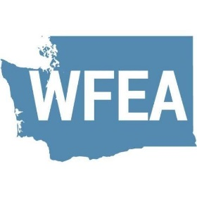
Washington Festival and Events Association Press Release
For Immediate Release Bruce Skinner, Executive Director
360-808-3204, bruce@wfea.org

(Name) ___________________________________, (Title) _____________________________________ Of (Organization/Festival)_________________________________ attended the Washington State Festival and Events Association 26th Annual Conference April 3-5, 2019 in Bellevue.

(Quote from participant) “The conference was an incredible experience with over thirty (30) professional development sessions. I learned and generated new ideas to take (name of festival or event) to the next level in professionalism and experience for our attendees. I rekindled old friendship and built a network of festival experts from across the Pacific Northwest and beyond.” Said (name).

While at the Conference (name of Festival) received (place and name of Summit award) for the best of the best in Festival and Event (insert category). Entries were judged by professionals in their fields of radio, television, photography, website development, promotions, graphics, advertising, public relations, marketing, social media, and special event production.

About (Name of Festival)
Name of Festival is managed by (name of organization) ____________________________________with the mission (insert your mission statement of purpose). It operates on an annual budget of ($) and with a staff of (#) and more that (number of volunteers) who provide more than (volunteer hours) annually. The proceeds of (name of festival or event) are used to (state where net proceeds go) to make a difference in (name of community)

About WFEA
The Washington Festivals & Events Association (WFEA) is a corporation dedicated to promoting the common business interests of the festivals and events industry in Washington State. The Association seeks to assist members and the special event industry to improve and advance industry standards by providing professional and leadership development, and technical assistance state-wide for the festivals & events industry. The association serves all manners of the event production industry including: chambers of commerce, community based non-profits, visitor and convention bureaus, park departments, government agencies, fairs, vendors, suppliers, consultants and hosts of volunteers. Community festivals and events play a vital role in a region’s identity branding directly affecting their tourism and economic development potentials. WFEA works continually to improve the understanding, recognition and appreciation of festivals and events in this complex community identity and economic process. Festivals and events create the venue for communities to come together to share and celebrate their arts, heritage and unique characteristics.
Washington's festival and special events industry makes a valuable contribution, both economically and culturally to the people of the Evergreen State. Community events held throughout the year generate millions of dollars for the economy through the millions of visitors the events attract.

